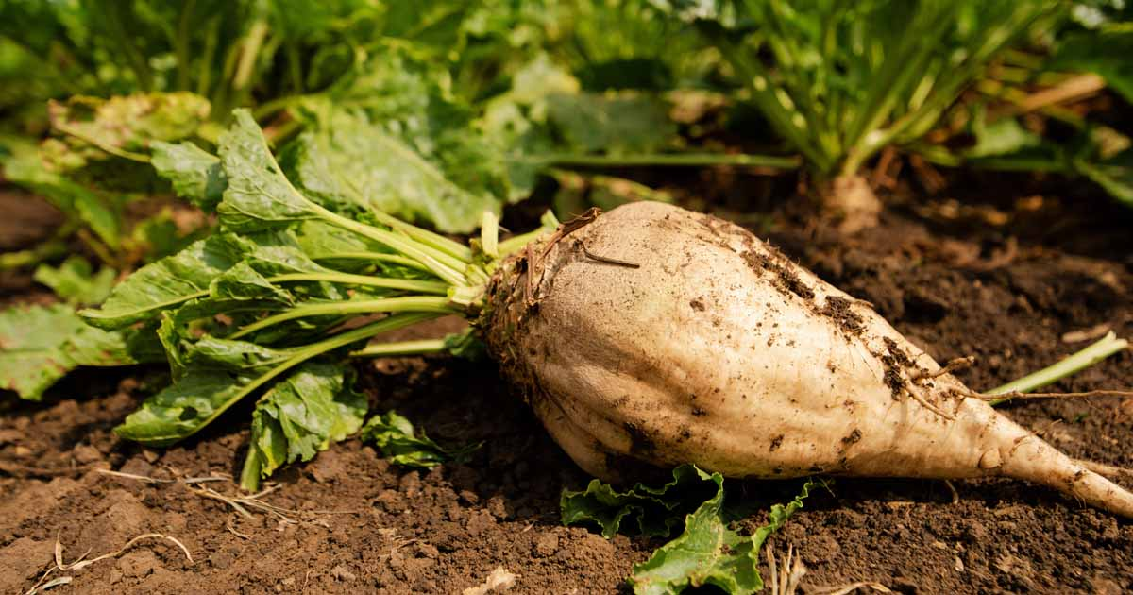 | 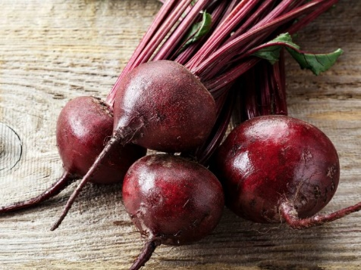
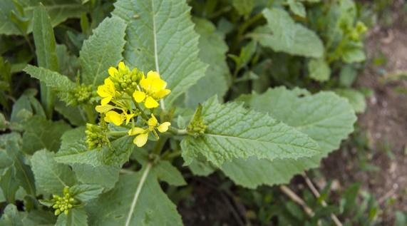 | 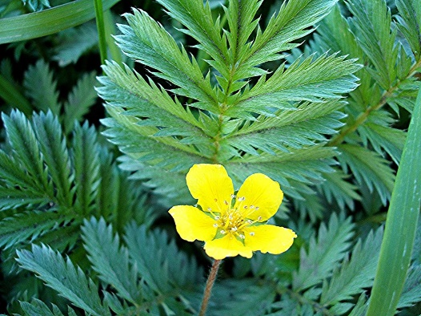
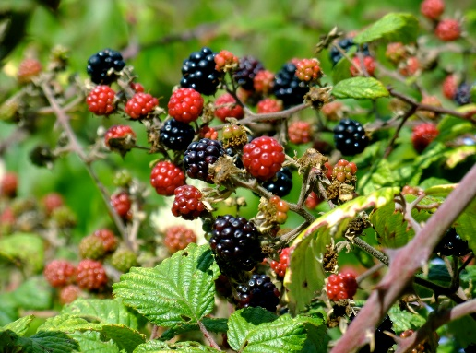 | 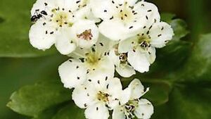
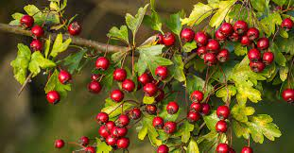 | 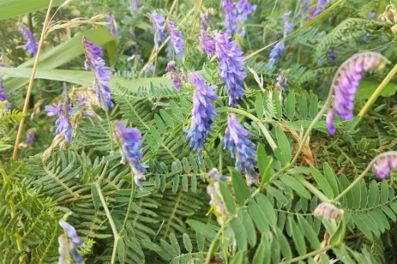
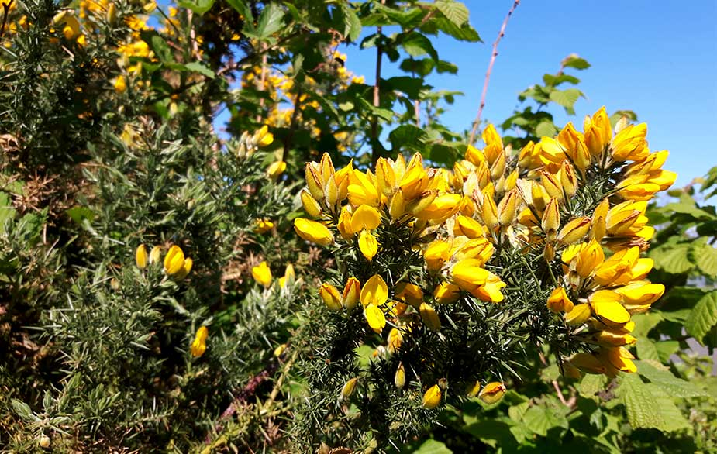 | 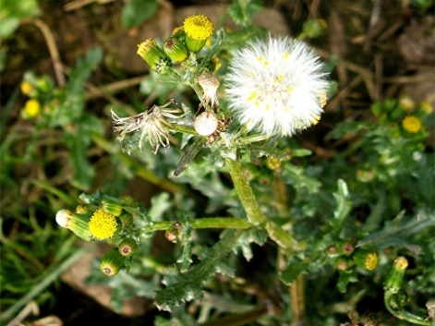

Beetroot | Sugar Beet
Silverweed | Charlock
Whitethorn/ Hawthorn | Brambles/ Briar
Vetch | Whitethorn/ Hawthorn
Groundsel | Gorse

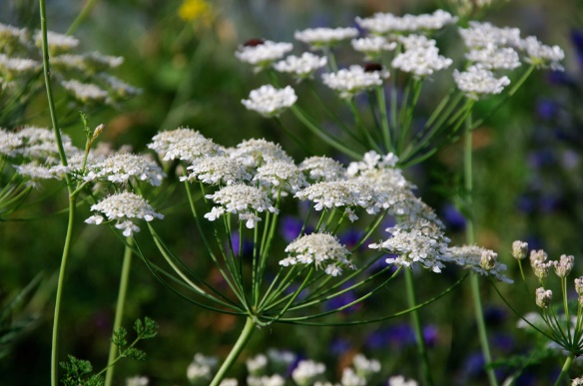 | 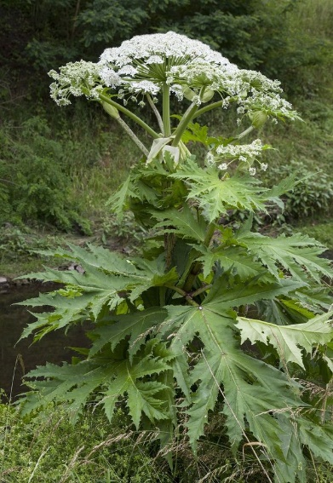
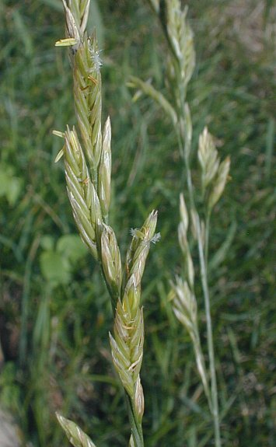 | 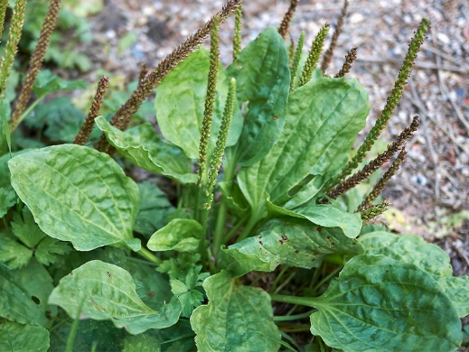
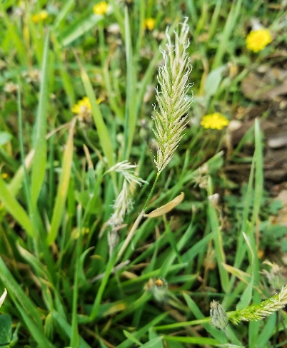 | 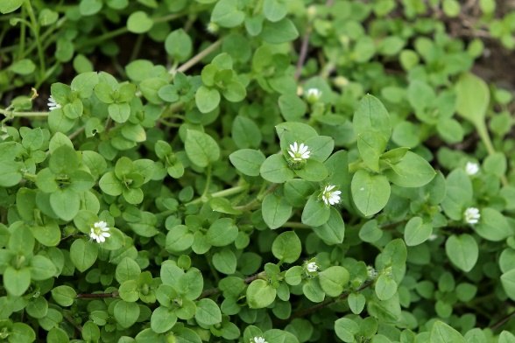
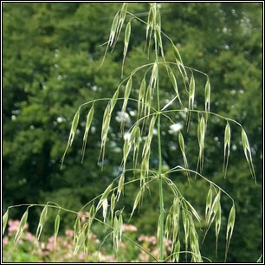 | 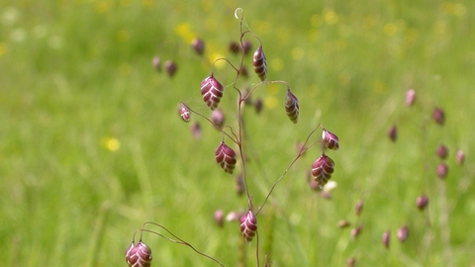
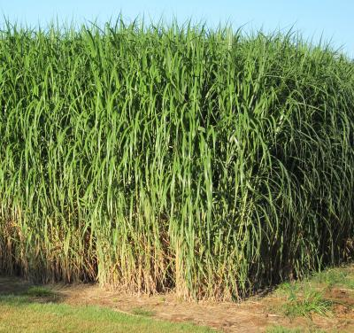 | 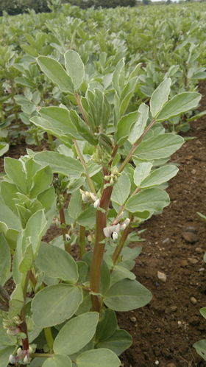

Giant Hogsweed | Cow Parsley
Plantain | Meadow Fescue
Chickweed | Sweet Vernal
Quaking Grass | Wild Oats
Beans | Miscanthus Giganteus

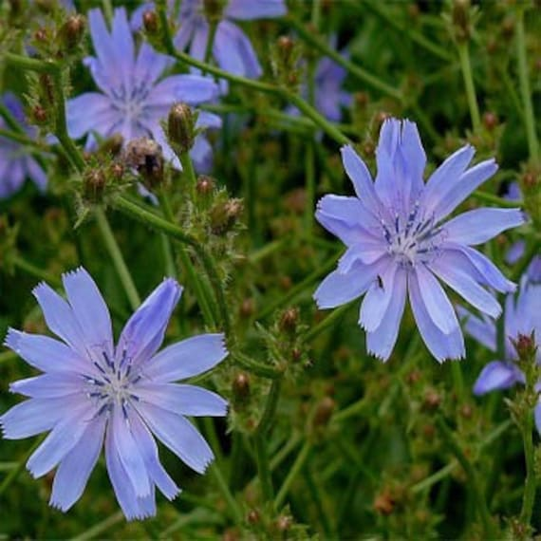 | 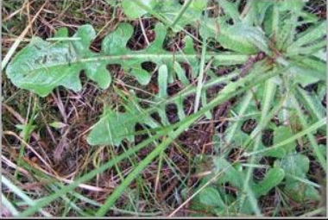
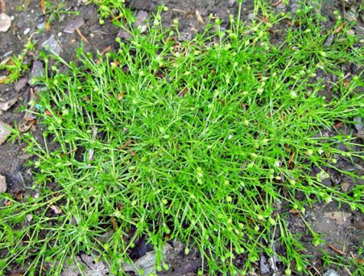 | 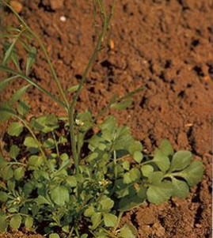
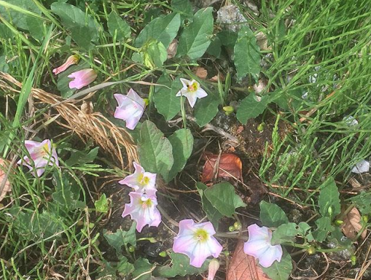 | 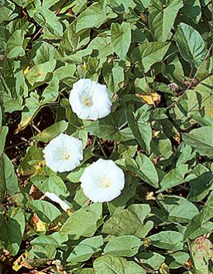
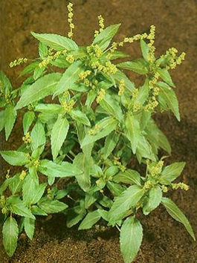 | 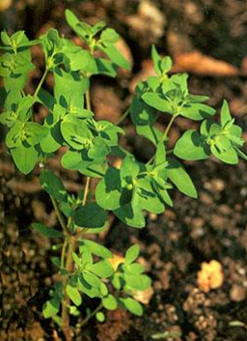
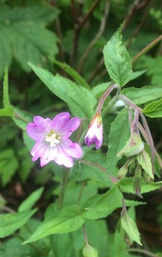 | 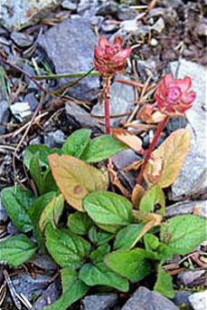

Cat’s Eye | Chicory
Hairy Bitter Cress | Pearlwort
Hedge Bindweed | Field Bindweed
Petty Surge | Annual Mercury
Selfheal | Broad Leaved Willowherb

Image Sources:
Teagasc.ie
https://gardenerspath.com/plants/vegetables/grow-sugar-beets/
www.medicalnewstoday.com/articles/277432
https://www.notcutts.co.uk/garden-advice/problems-pests/charlock/
https://www.naturespot.org.uk/species/silverweed
www.flowerpotman.com/garden-pest-control/how-to-clear-bramble/
www.irishexaminer.com/opinion/columnists/arid-20405734.html
www.healthline.com/nutrition/hawthorn-berry-benefits
www.wildwalks-southwest.co.uk/wild-food-common-vetch/
britishlocalfood.com/gorse/
www.naturespot.org.uk/species/groundsel

https://www.irishwildflowers.ie/pages-grasses/g-26.html
seedball.co.uk/product/cow-parsley-50/
gardenerspath.com/plants/vegetables/grow-sugar-beets/
https://www.illinoiswildflowers.info/grasses/plants/mdw_fescue.htm
https://www.healthline.com/nutrition/plantain-weed#_noHeaderPrefixedContent
https://www.britannica.com/plant/Poales
https://plantura.garden/uk/herbs/chickweed/chickweed-overview
https://www.wildlifetrusts.org/wildlife-explorer/grasses-sedges-and-rushes/quaking-grass
https://www.eurekalert.org/news-releases/781932
https://www.teagasc.ie/crops/crops/break-crops/beans/
https://www.etsy.com/ie/listing/500647554/chicory-flower-seedscichorium
https://www.cropscience.bayer.ru/uploads/s1/attachment/5c74eba24bb4a.jpeg

